ÇANKAYA UNIVERSITY • CENG 382 WEB DEVELOPMENT
2024 – 2025 Spring

FINAL PROJECT REPORT

Project Name: Reservation System Project

Name, Surname: Mert Ali Mucuk
Student Number: 202111059

19.05.2025

Youtube link for project : https://youtu.be/WRQYS4bQueM
- Project Information and Objectives
- Project Scope:
The scope of this project is a web-based system designed to facilitate the reservation of classrooms by instructors within an academic institution. The system allows instructors to submit reservation requests for available classrooms during academic terms. An administrator is responsible for the overall management of the system, which includes defining and managing academic terms, creating and managing instructor accounts, approving or rejecting reservation requests, handling scheduling conflicts, and monitoring user feedback regarding classrooms and the system itself. The platform aims to provide an efficient, user-friendly, and reliable solution for classroom scheduling.

- Users:
Administrators (Admin): Responsible for system setup, management of terms, user accounts (instructors), overseeing reservation requests, resolving conflicts, and monitoring feedback.

Instructors:Academic staff who will use the system to view available classrooms, submit reservation requests for their classes, request modifications or cancellations for their existing reservations, and provide feedback on classrooms or the reservation experience.

User: A system user who is not an instructor or admin and can give feedback about classes.

- Objectives:
- The system shall provide password-protected access to distinct Admin and Instructor panels, ensuring role-based functionalities and data visibility.
- The system shall allow Administrators to define, edit, and manage academic terms (semesters), including setting an active term during which reservations can be made.
- The system shall enable Administrators to create, manage, and view instructor accounts.
- The system shall allow Instructors to submit classroom reservation requests for specific dates and time slots within the currently active academic term.
- The system shall implement a mechanism for Administrators to review, approve, or reject reservation requests submitted by instructors.
- The system shall automatically detect and flag scheduling conflicts if two or more reservation requests overlap for the same classroom and time slot. Conflicting requests must be resolved by the Admin before approval.
- The system shall integrate with an external public holiday API (I used Google Calendar API) to check if requested reservation dates fall on official holidays and provide warnings to both Admins and Instructors.
- The system shall feature a "Contact Us" section for general inquiries and a dedicated feedback mechanism allowing users to submit 5-star ratings and comments for specific class sessions or classrooms.
- The system shall allow Administrators to view class-specific feedback, including average star ratings on a main class list and detailed feedback on individual class detail pages.
- The system shall provide a responsive calendar view (weekly and monthly) for both Admins (all reservations) and Instructors (their own reservations), powered by an external add-on.
- The system shall allow Instructors to request modifications or cancellations for their existing reservations, subject to Admin approval.
- The system shall support recurring reservation requests, where an instructor can request a specific time slot to be applied to all relevant days throughout the active term.
- The system shall implement security measures, including hashing and salting for all user passwords.
- The system shall maintain detailed system logs for all significant user actions (login attempts, reservation submissions/changes/deletions, admin approvals/rejections, feedback submissions) and system errors, stored securely for auditing(I used database for this).
- The system shall send automatic email notifications to instructors regarding the status of their reservation requests (approval, rejection, holiday warnings).
- The user interface shall be visually professional, responsive, and suitable for an academic setting, utilizing Bootstrap.
- Edit operations (e.g., user info, reservations, term details) shall be handled using modals or visually appealing inline components to avoid full page reloads where appropriate.
- The system shall feature a dark/light mode toggle for user interface theme preference (Bonus Feature).

- Project Implementation

  - Database Diagram:
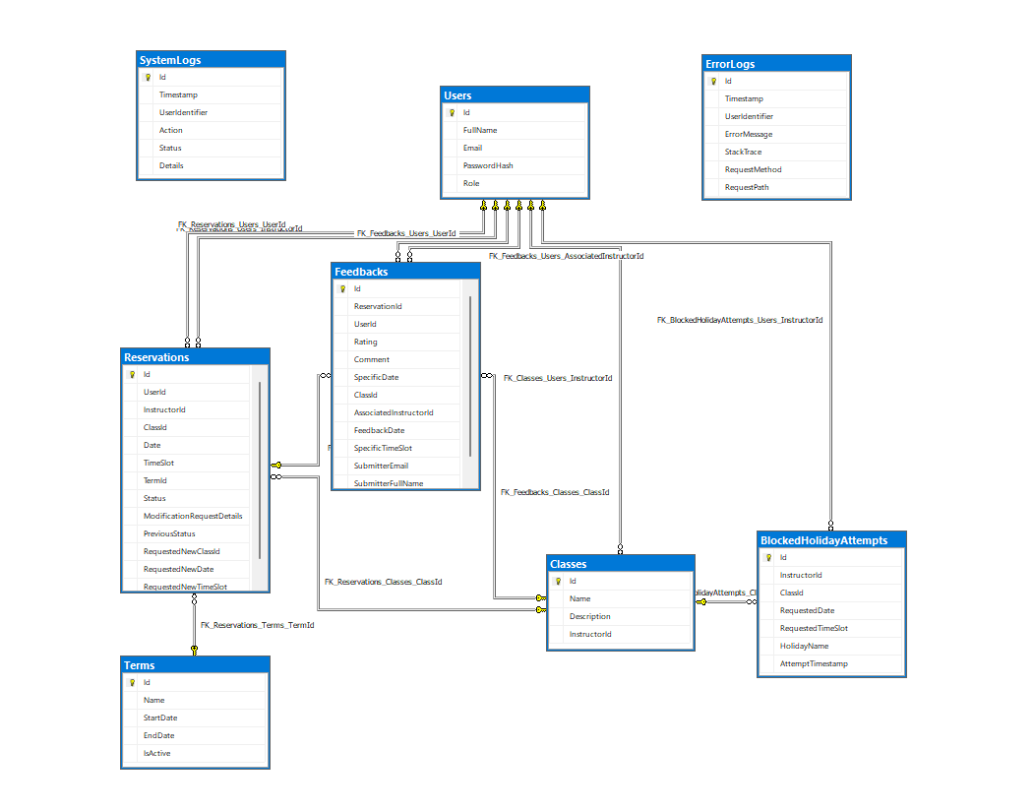
Figure 1 1 Sample Database Diagram

  - Context Diagram:

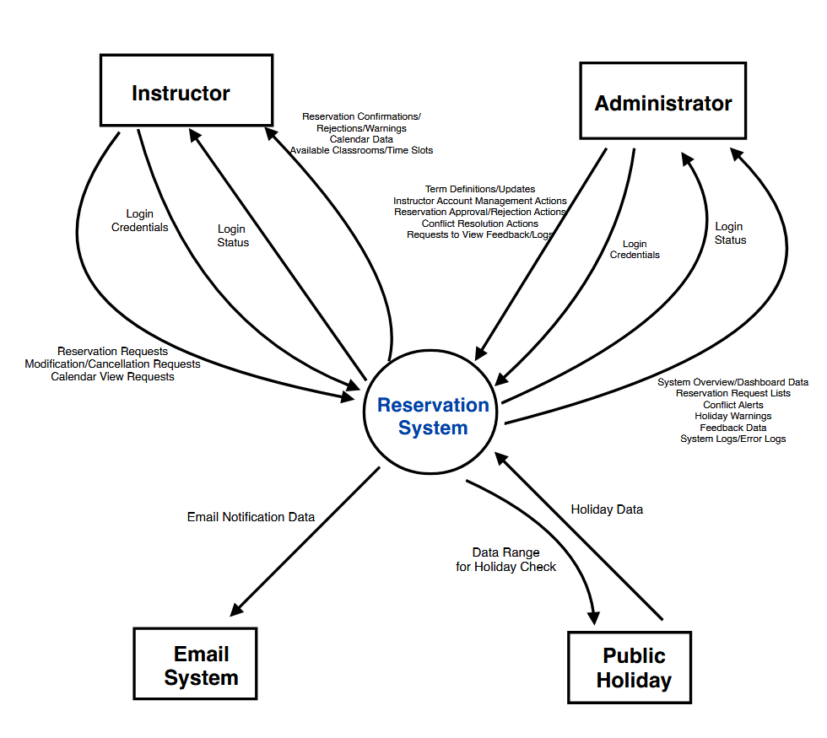
Figure 1 2 System Context Diagram

  - Workflow Diagrams

1-Instructor Workflow Diagram 2-Admin Workflow Diagrams

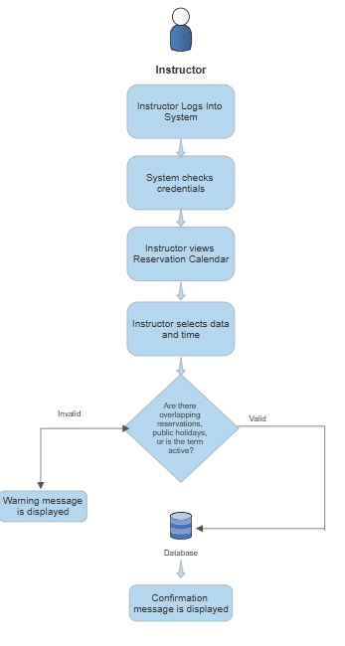
Figure 1 4 Admin Workflow Diagram
Figure 1 3 Instructor Workflow Diagram

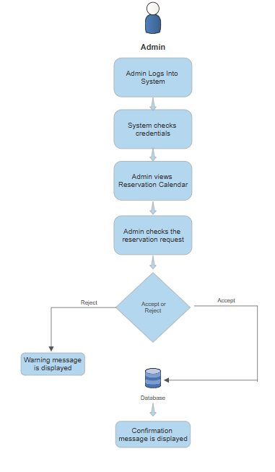

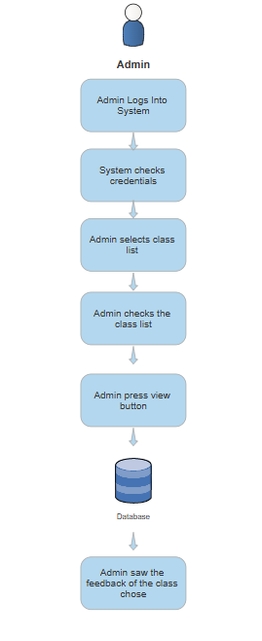
Şekil 1.6 Admin Class List Panel Workflow Diagram
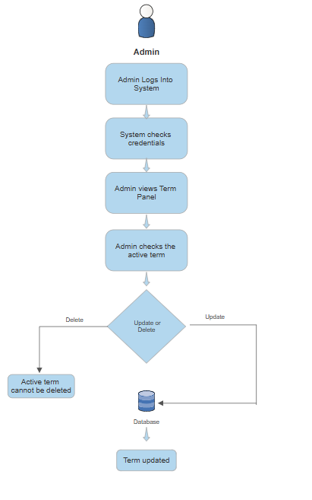
Şekil 1.5 Admin Term Panel Workflow Diagram

3-User Workflow Diagrams

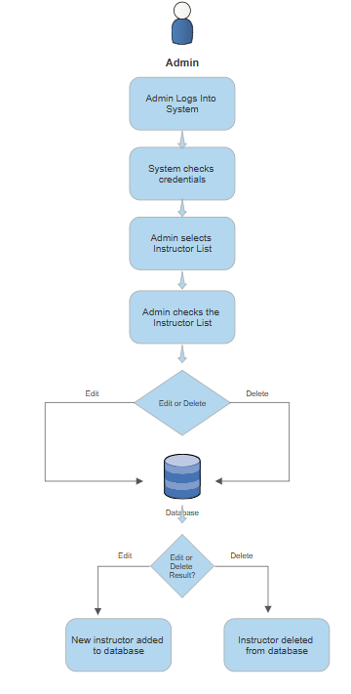
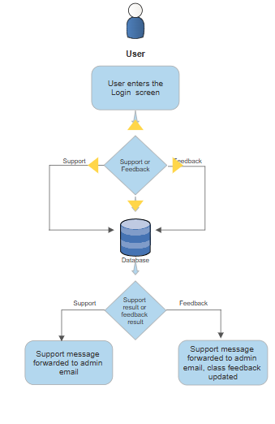
Şekil 1.7 Admin Instructor Panel Workflow Diagram
Şekil 1.8 User Feedback Panel Workflow Diagram

3. Project Results:

- Login Screen: This screen is the main screen of my application, you can observe the dark mode and light mode versions and the feedback and support sections at the bottom of the screen.

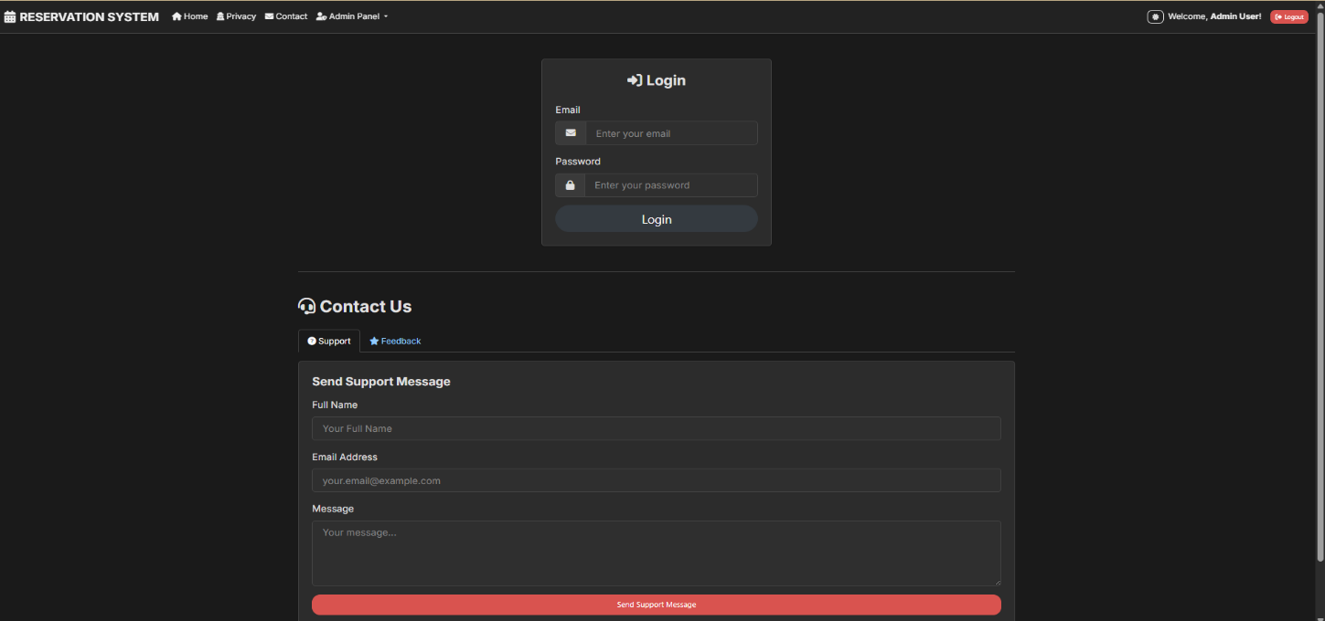
Figure 1.9 Login screen with dark mode

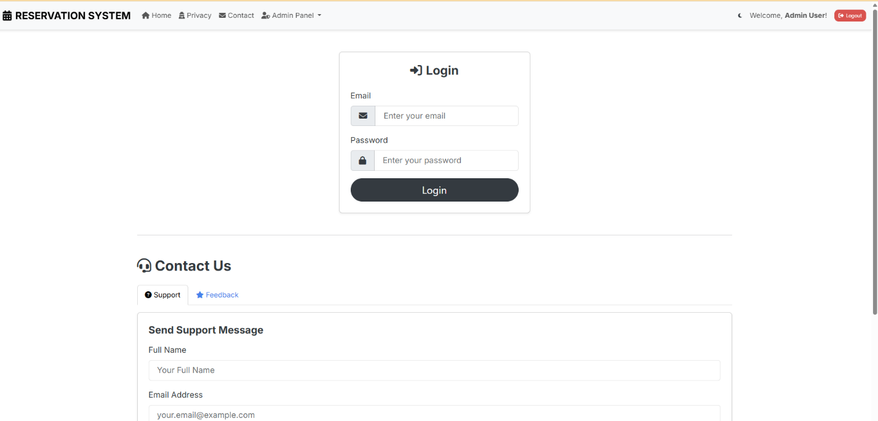
Figure 1 10 Login screen without dark mode

- Contact Us section: In this section, there are support and feedback sections used by users who want to give feedback to the system in my contact us section. It is at the bottom of the login screen.
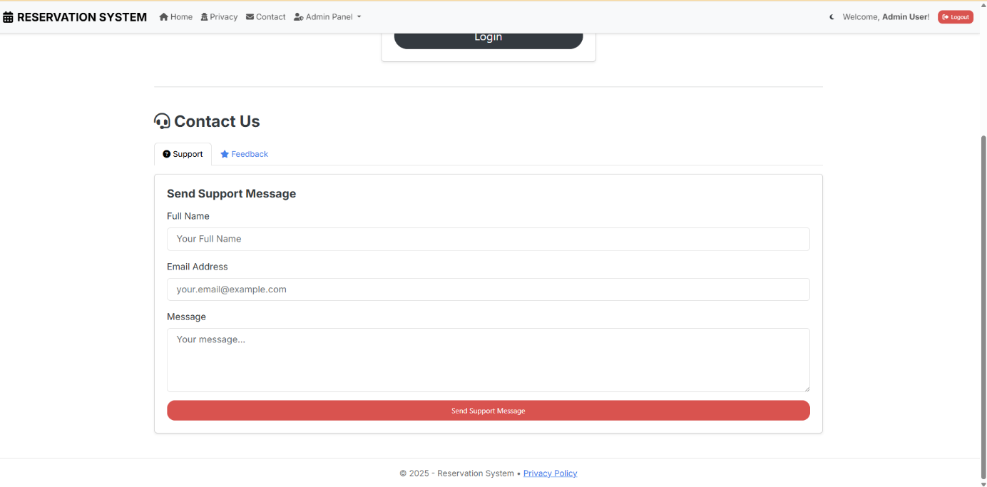
Figure 1 11 Contact Us support section

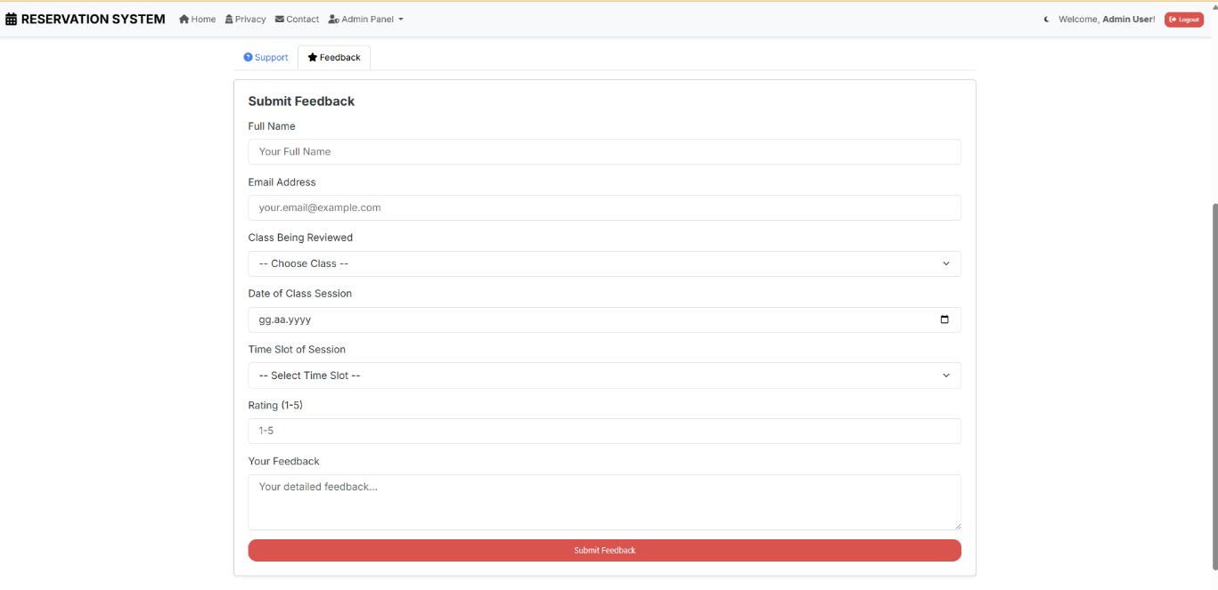
Figure 1.12 Contact Us feedback section

- Instructor Panel: In this section, you can view the visual of my instructor panel in dark mode and white mode. The photos below are a group of 2.

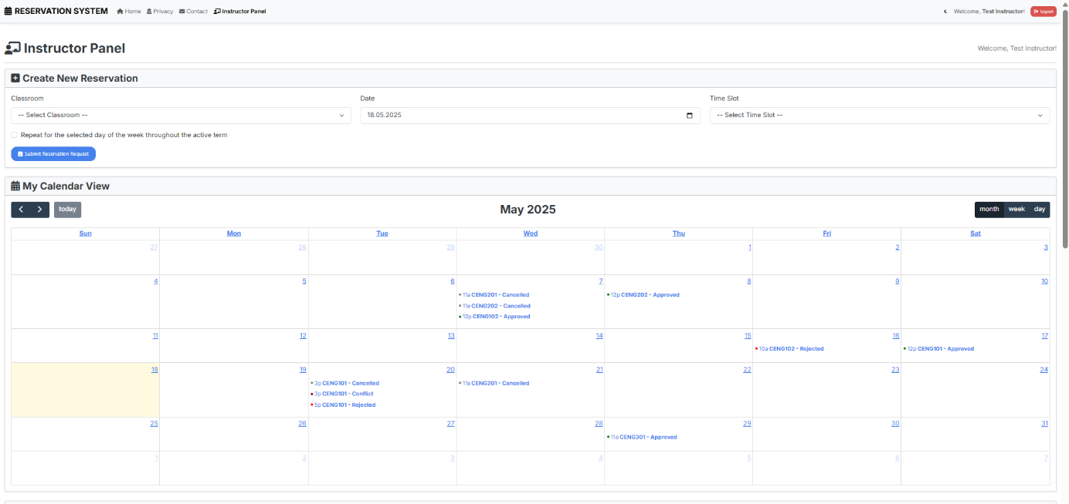
Figure 1 13 Instructor login screen top part without dark mode(calendar)

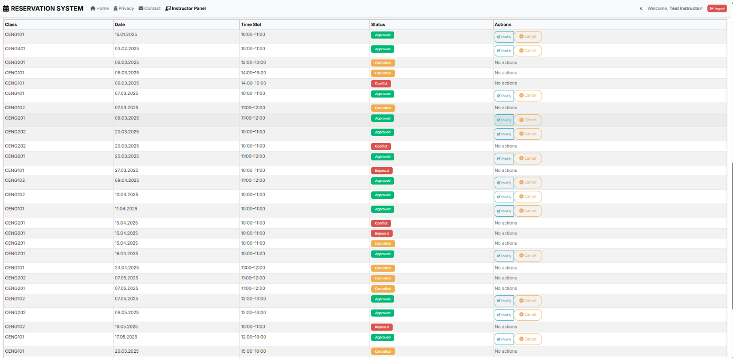
Figure 1 14 Instructor login screen top part without dark mode (all reservation request)

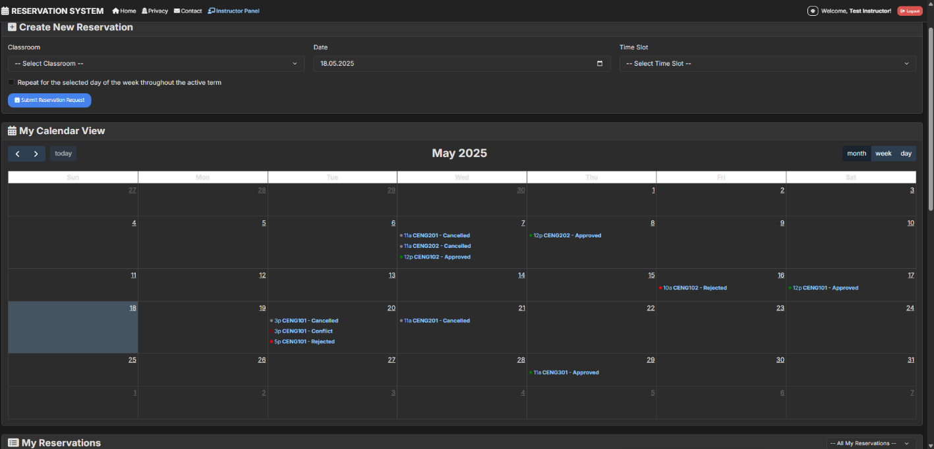
Figure 1 15 Instructor login screen top part with dark mode

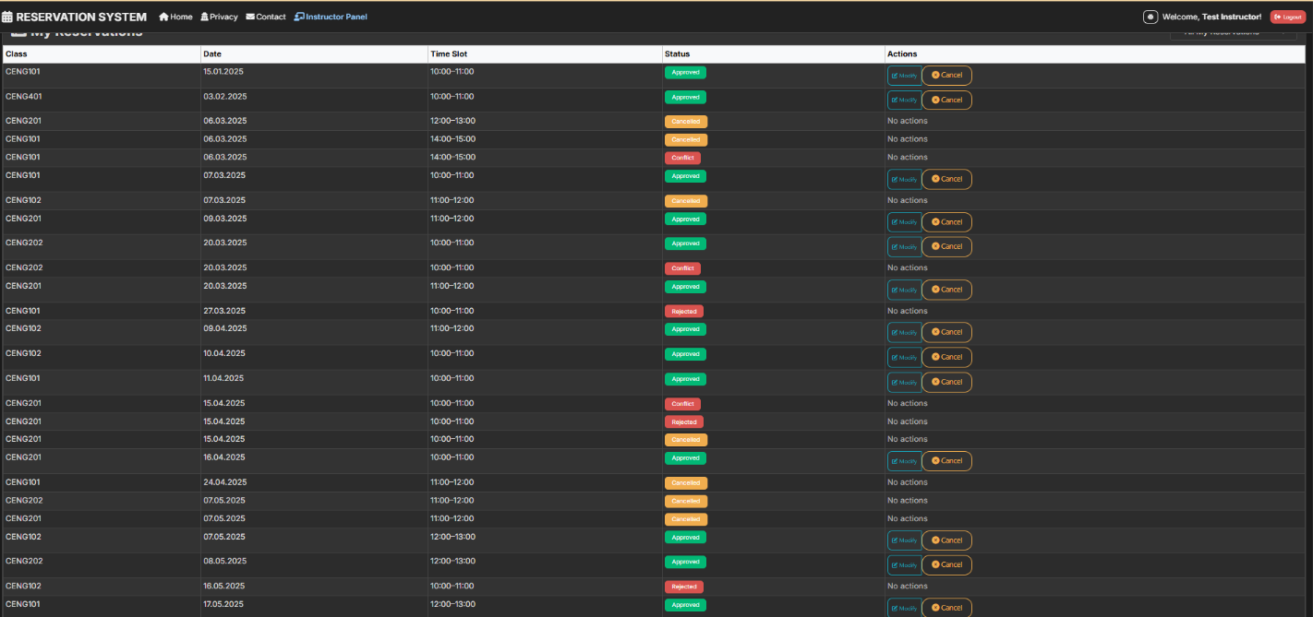
Figure 1 16 Instructor login screen bottom part without dark mode

- Admin Panel: In this section, you will see the admin login page that appears after logging into the system.

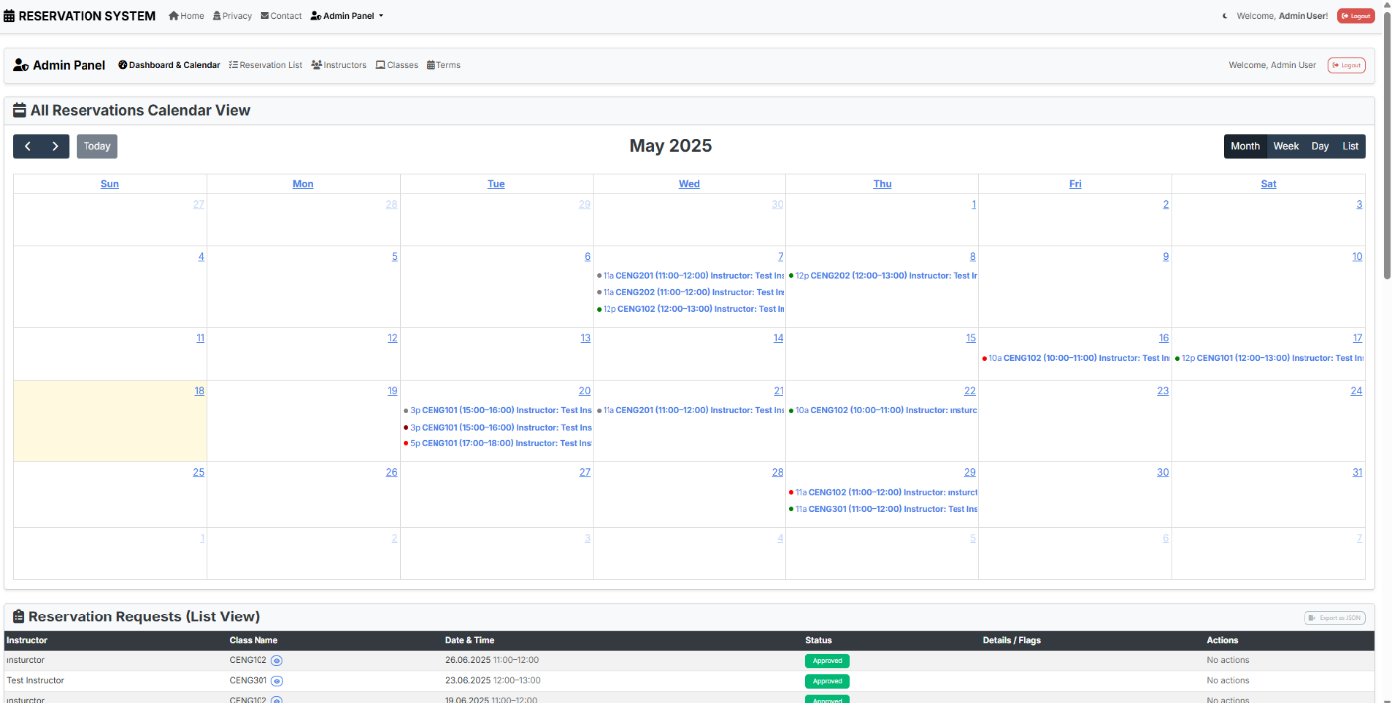
Figure 1 17 Where admin sees dynamic calendar

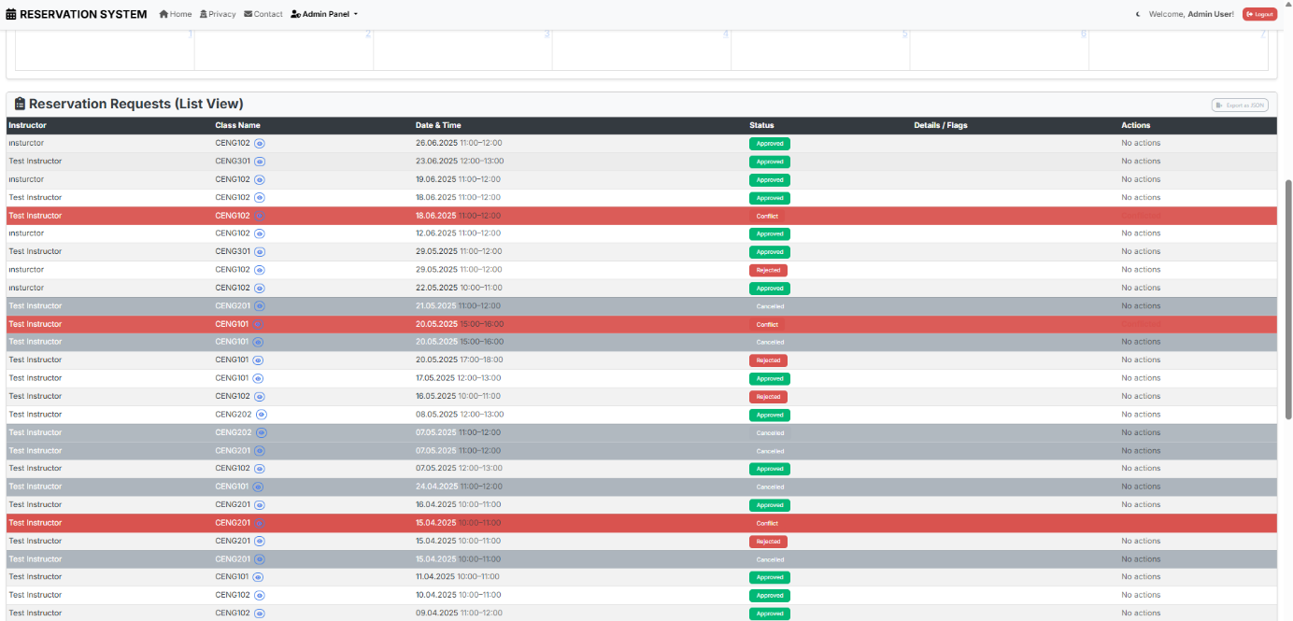
,
Figure 1 18 Page where admin sees reservations

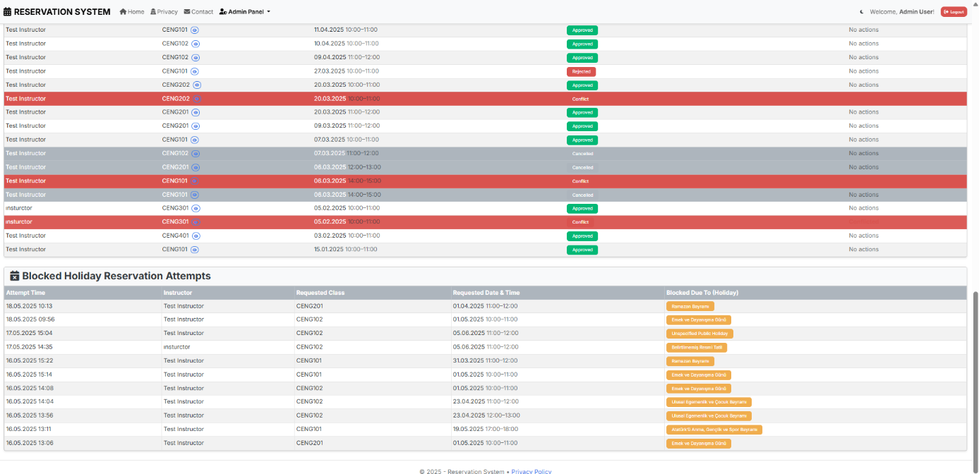
Figure 1 19 Screen where admin sees public holidays

- Admin Panel/Instructor Managment Screen: The part where see the instructors registered in the database and can add or delete instructors(dark mode).
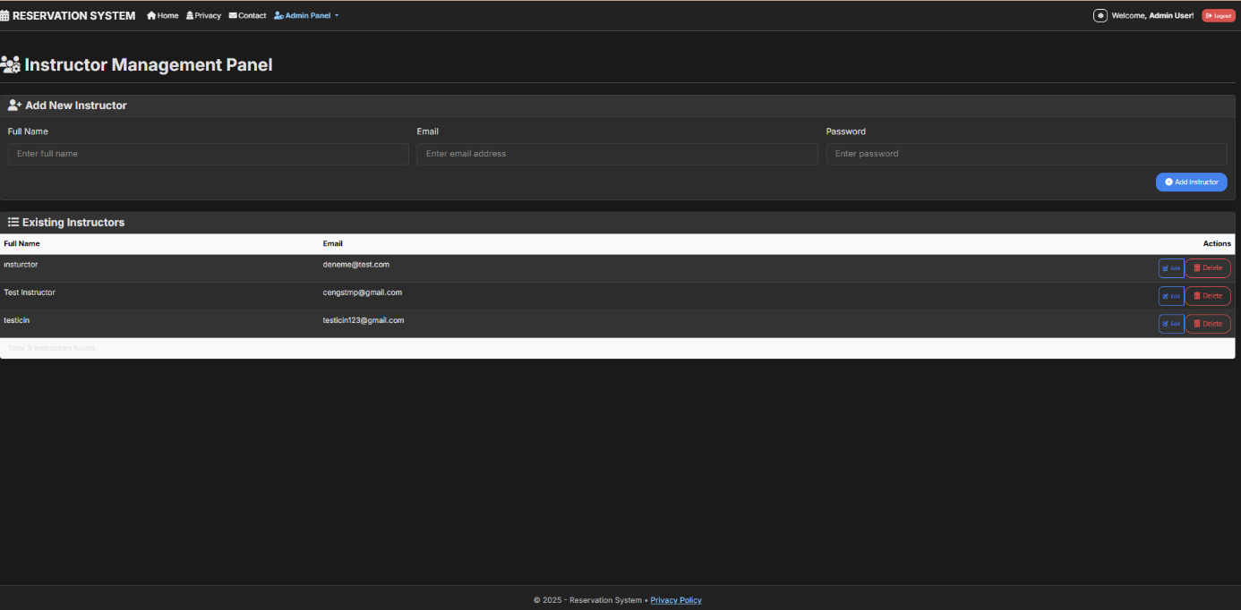
Figure 1 20

- Admin Panel/Academic Term Managment Screen: Screen where admin can manage academic term
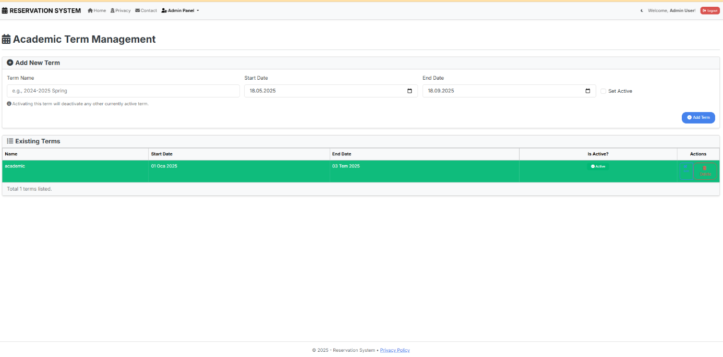
Figure 1 21

- AdminPanel/Instructor List Screen: Screen where I can see the number of classes registered to all instructors (additional feature to the project)

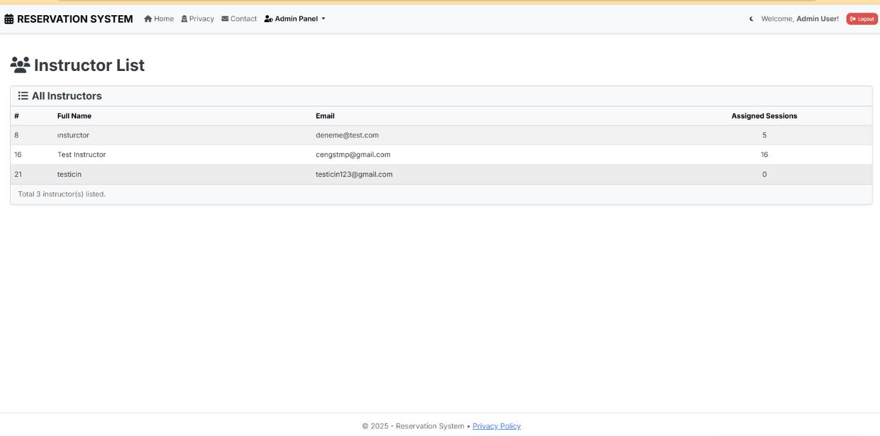
Figure 1 22

- AdminPanel/Class List Screen: System where admin can see all class details

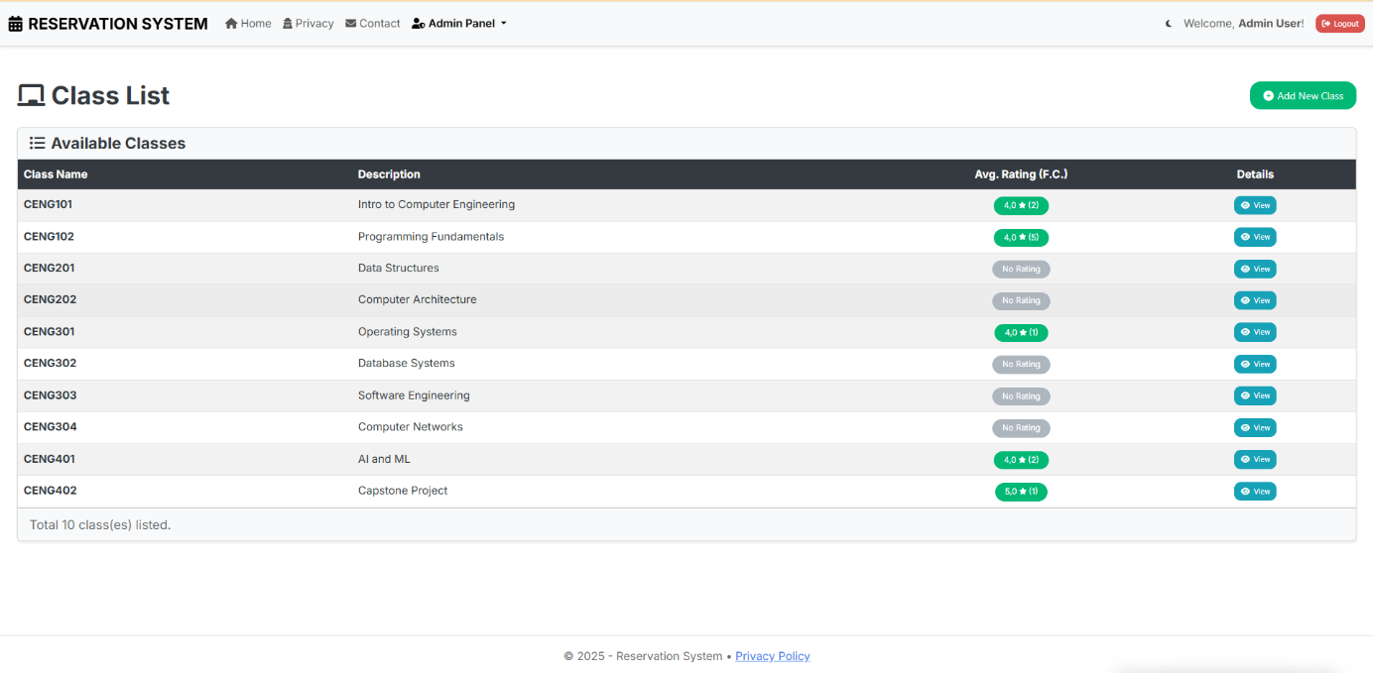
Figure 1 23 the information about the classes in detail.

- AdminPanel/Class List/Detail Screen: The screen where the admin pansees

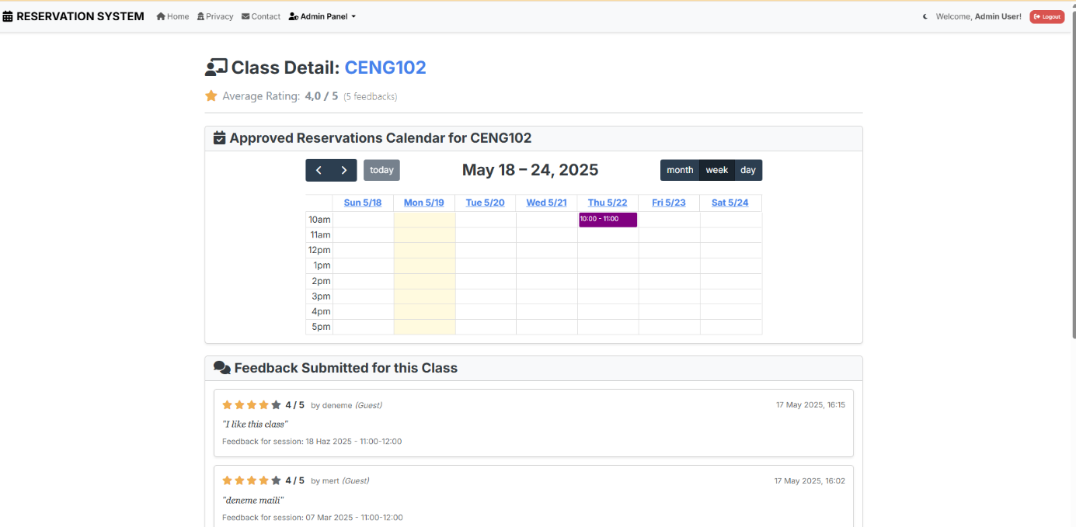
Figure 1 24 the feedback about class with dynamic calendar.

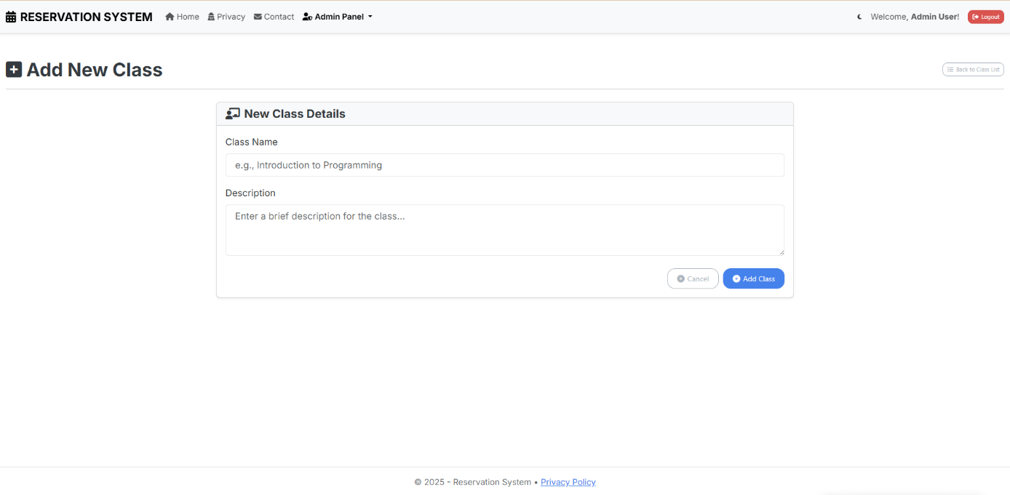
- AdminPanel/Add New Class Screen: A system where the admin can add courses opened at the end of the year. (I added them myself, outside the scope of the project)
Figure 1 25 Courses add panel-- additional system

